MISIONEROS MARISTAS, BOLIVIA
Email: cebstarija@yahoo.com.mx
Cel: [591] 65813351/67370859/72

June 21st2022: Andean-Amazonian New Year
Dear Friends,
One finds it hard to believe that we are, in these days, approaching mid-year 2022. It is not only we oldies who find that to be the case but the younger folk also. Here our Marist Community in recent years has had motive to celebrate various landmarks in our journey together. 30 years of its foundation in 2020, Gilberto and Armanda’s 25th Wedding Anniversary in 2021 and Juan’s 50th Ordination Anniversary in 2021. On June 25th of the current year, Juan celebrates his 77th birthday. What is its significance for us? Well, it has a lot of biblical significance!

Here is a sampling of what “Google” comes up with regard to reaching 77 years:
- In a personal sense and according to the Bible, 77 shows the right time to develop inner peace and spirituality, and when you do, it is perfect to look at all that you have done and rest.
-77 is associated with courage and independence, and when it is your number, and then it shows the power of being free.
-the New Testament chronicles 77 generations that go from Adam to Jesus.
-77 represents a sign of completed cycle and the beginning of a new round and directs you in the right direction, the spiritual direction, towards “perfection”. Only God is perfect, but the discovery and finding out who you are and who you can be, is what matters.
-in the Bible, 77 shows fullness and completion, all things that are good or/either perfect.

So reaching 77 years is the right time to consider and plan the years remaining in one’s journey in life. Juan has now spent 45 years at the service of the Latin American Church and the last 33 of those in Bolivia. We have served now the Tarija Diocese for some 22 years and do not see ourselves taking on the opening of a new mission in future years in other parts. We have our community residence in Tarija City and now have developed our retreat/rest house in a rural community some 40 minutes from the city. The village is called “Pantipampa” where the Marists enjoy a very warm friendship with the community and can be seen as inserted in the community to the point where Juan can select the plot where he wishes to be buried in the new community cemetery! Meanwhile he is the honorary president of the local soccer team.

For Juan’s 77^{th,} the Marist Community has decided to make it a special celebration in view of its biblical significance. At our Pantipampa Retreat we will be roasting two lambs over the coals to be serve at the luncheon, accompanied by some local red wine for which Tarija is famous. We have invited a group of neighbours along with the youth group of CEBs [Base Church Communities]. Thereafter, we hope that Juan will enter into a new phase in his life, not to retire completely, but to be freed from responsibilities in relation to the institutional church while maintaining his accompaniment and involvement with the Base Church Communities. To be free to have time and be present to the people in a new way that perhaps when one is so tied to the system, one is limited. Now Juan’s energies and experience can be much more effective as he sets about to enjoy what some call “the Golden Years”. The best of him is yet to come!

To conclude our reflexion concerning Juan’77th, we have some “GOOD NEWS” to share with you. Gilberto and Javier came together with Juan to found this community of Misioneros Maristas in 1990 when they were 24 and 22 respectively. Some consider them as Juan’s “Hijos-sons” as well as his brothers in community. When they married and had their children from Day One, Juan José, Chiqui, Lupo, Paco and Marian have known him as “Abuelo –Gran Dad”. Gilberto’s Chiqui and his spouse were blessed with their first-born on April 28th and so in our Marist Community Juan became a “Great Grand Father”…..3 generations. Chiqui and Paula have called their son “JOHN” after his Gran Abuelo. So his Birth Certificate reads “JOHN PATANA” and not “JUAN Patana” [the Spanish translation of the English name of John is Juan]. Great Grand Dad Juan is so delighted and proud. JOHN PATANA was born 5 weeks ahead of time but has quickly developed and is just so gorgeous….like his great grand dad!!!
Now to commemorate this occasion, Javier wishes to share with you his reflexion regarding our journey together as Misioneros Maristas:-

ARTISAN OF THE KINGDOM

We begin by quoting a phrase from the German poet Bertolt Brecht “There are men who fight one day and are good. There are others that fight for a year and are better. Some fight for many years and are very good. But there are those who fight all their lives: those are the essential ones.” With respect to the poet and to you, I dare to modify some words of this famous phrase: “There are men who love one day and are good. There are others who love a year and are better. There are those who love for many years, and they are very good. But there are those who love for life: those are the lifeblood.”

On one occasion, 32 years ago, during our first spiritual retreat, which definitively marked us for the rest of our lives, I had a dialogue with one of the nuns from the Daughters of the Church congregation. I remember her name very well, Sr. Felicidad Paniagua. She told me: "When the Lord touches you, he will never let you go; throughout your life he will be present pricking you." Those words are still ringing in my ears.

During this walk together, in this adventure of life and mission, the Good God of Life gave us many moments that have enriched our lives: he put us to the test through crises as an opportunity for growth, demands of all kinds to measure our capacities of response to renew and strengthen us. Likewise, we have lived moments of beautiful joy as a family and as a Missionary team; we have savoured the Good News as a gift from the creator, building and strengthening our unity as a living and humble testimony.

There are 32 years of journeying so many paths; in that journey Juanito was the one who assumed that service of being the guide, the shepherd, the teacher, the all-rounder. Walking those paths sometimes to the point of exhaustion. I have asked myself… Where does all that strength and energy come from? In light of the words of that nun, I believe it was that God, that Good God, who one day touched him and from that moment on, he did not let go.

His life was a journey; the years lived in total donation, an act of love, an act of faith, of those that give you light and encouragement in the face of the darkness of existence. In that journey, after spending so many years in the front line of combat, this great Australian missionary, on this June 25, celebrates seventy-seven years, years lived with deep and unassuming passion as a good artisan of the Kingdom.

The popular saying goes "the years do not pass in vain". I have seen a few times that the energies are no longer the same in him. Hopefully human beings continue to emerge, those who are essential because they love all life. Now it is his turn to slow down, although surely he will always want to be involved, to be with the people and continue giving himself in this designation that the Good Lord had already prepared for him since before he was born. He now has to live the mission in a calmer or quieter way, knowing that the seeds he sowed will soon bear fruit and good fruit.

Juanito, as your brother and companion in life and mission, I join this occasion, I give thanks for your life, your friendship, your company in this magnificent life adventure.
Your brother and companion: Javier and family.

MOKOMOKAL - THE KINGDOM OF GOD INTERRUPTED
Mokomokal, is the name of one of the communities of the Guaraní people that experienced a “Flood” (as Alejandra says), on February 20 at 11 p.m.

After three months, in the recent visit made by us "Marist Missionaries", on May 25 we found a great surprise: the municipal, departmental and national authorities had already completely left the disaster zone, leaving to their fate the Mokomokal Community and the others.

As a consequence of this abandonment, many, many real needs came to light in the lives of our sisters and brothers in the community. And that is what I am going to share with you:

It was almost 11 a.m. on Wednesday, May 25, when we arrived at the community, and it was already time for the women to return from the common work they do, cleaning the area where the new community is going to be, since the flood. The community is not and will never be habitable again, since the flood destroyed more than 70% of the area.

Alejandra Ibáñez, community animator, whom we first met, knew that our visit was not for a reflection meeting and that rather we went to learn about the new location of the community and listen to concerns in the three months of living in this post-flood reality.

Alejandra and we set off towards where the women were working and on the way we first met Iver Achuma, Alejandra's husband and also an animator, who set out with us and later we met Eusebio who offered us water to cool off. In about 10 minutes, we reached the field and stopped in the shade of a tree. From that place, we were able to observe some tents with corrugated iron roofs built by members of the community.

Among the conversations about the life of the community, many situations of need arose such as: "we have to build ourselves", "we don't have water", "food is running out", "there is no light here", "there is no longer support with machinery", "the health concerns us”, “Save the Children leave the community”.

When Alejandra said, "We have to build ourselves" questions arose on our part, "Why you" for example. So, she told us that while the national government arrives with the construction of houses for the 8 families that lost everything in the disaster (family members, house, goods, and animals). “We have to temporarily build the houses. We work together, one day for one and another day for another”.

Alejandra kept saying, “We don't have water”. It was true because the flood destroyed the entire drinking water system of the community and being in the new location there is absolutely no water. However, there is much hope of connecting to one of two water networks that are not far from the site. On one hand, the water approaches the “Agua Buena Caldera” community and on the other hand, the water approaches the “Agua Buena Yukipita” community. In the community there are approximately 30 houses that need to have this indispensable element "WATER".

Talking about "food runs out", it is that. During the days of extreme emergency, institutions, organizations, communities appeared that in solidarity sent different items: (clothes, blankets, kitchen utensils, food, water and others) and the food that arrived, there is already little that will last until the end of June approximately. “And then we don't know what will happen”. Alexandra continued: "There is no light". In the new location of the community, there are two houses with electricity and the others have nothing.

"There is no machinery." Certainly it would have been great if the machinery of the Municipality had helped to level the land for the construction of the new community, but the authorities abandoned them and left them to their fate. For this reason, the women and men of the community work daily to carry out this work.

On the subject of Health, there is great concern since winter begins with severe cold and the risk of colds, especially in children. On the other hand, there is fear that “monkey pox” will break out in the community, since this disease is already in Bolivia. In the community there is not even a first aid kit.

Currently in the community there is present "Bolivia SOS Children's Villages", an institution that is dedicated to welcoming, feeding and teaching children in need. This institution approached the community due to the emergency and now they said that they are going to withdraw from the community this end of the month - June. Therefore, they expect the municipality to take charge of caring for the children.

Dear brothers and sisters, there is much to share about the lives of our brothers and sisters in MOKOMOKAL. What we share is really from the heart and full of great hope that life will soon be restored and the Kingdom of God will come to pass. We also want to say that despite this hard life experience in Mokomokal, each and everyone who lives in the community maintains their organization, their unity and their hope that God (Tupä) together with them will move forward in life over all adversity. And that is very Good News.

Thank you so much for embracing this true-life story in this part of the world. Gilberto.

A follow-up on what we mention in our Easter Letter as regards to the Mokomokal Soccer Team where we indicated that we had set-up the local lads with a complete set of uniform with their own colours and logo. Well, the following weekend after we presented them with this, they proudly fronted on in the regional tournament, decked out in their new gear to the surprise of the opposition, played as never before, and thus pulled off a glorious win. The prize was a heifer cow.

Back at our Marist residence and office here in the popular barrio of Lourdes in the city of Tarija we are adapting to the very cold winter…..the coldest since our living here. To date, we have all survived healthy.

We had some encouraging feedback from our Easter Letter and hope that you find the present one informative regarding our life and mission here as Misioneros Marists.
Let us continue to pray for each other. With all our love:

Gilberto/Arminda/Juan José/Chiqui-Paula-John/Marian - Javier/Nair/Lupo/Paco - Juan

==========================================================================
Important Notes:
1. We no longer have a Postal Address. Our Post Box is cancelled given that the Bolivian Postal Service is inoperative.
2. We no longer have a House Phone; Gilberto, Javier & Juan each have a mobile phone
& WhatsApp: Juan–[591]65813351/Gilberto-[591] 67370859/Javier-[591] 72950692.
3. The following 2 pages contain some photos related to what we have shared in our Circular Letters
and an Invitation to Juan’s Birthday Celebration on Saturday June 25th.

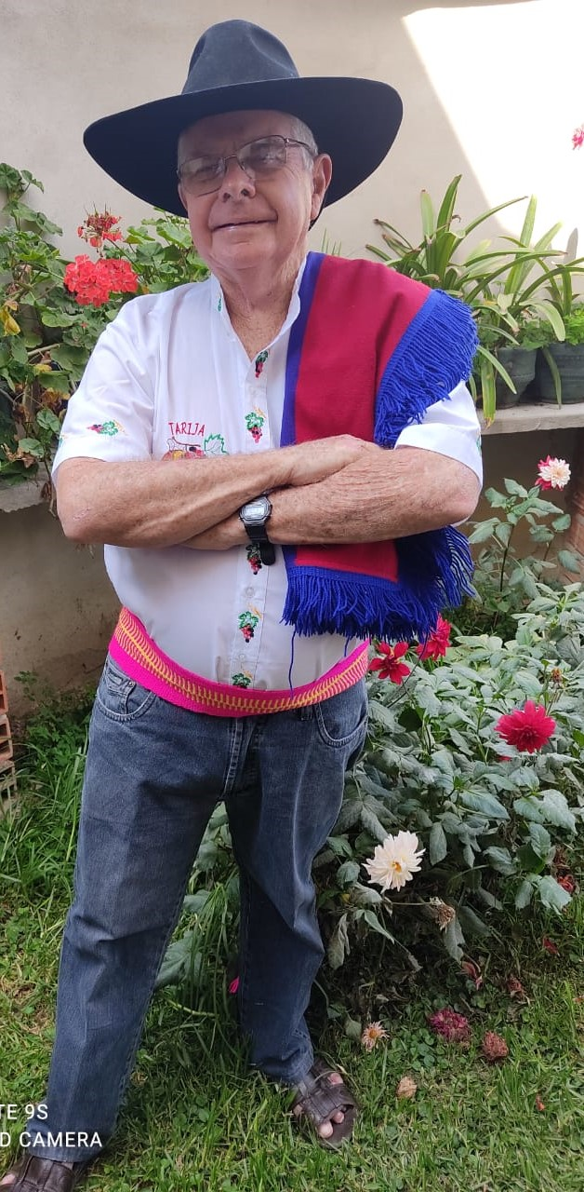
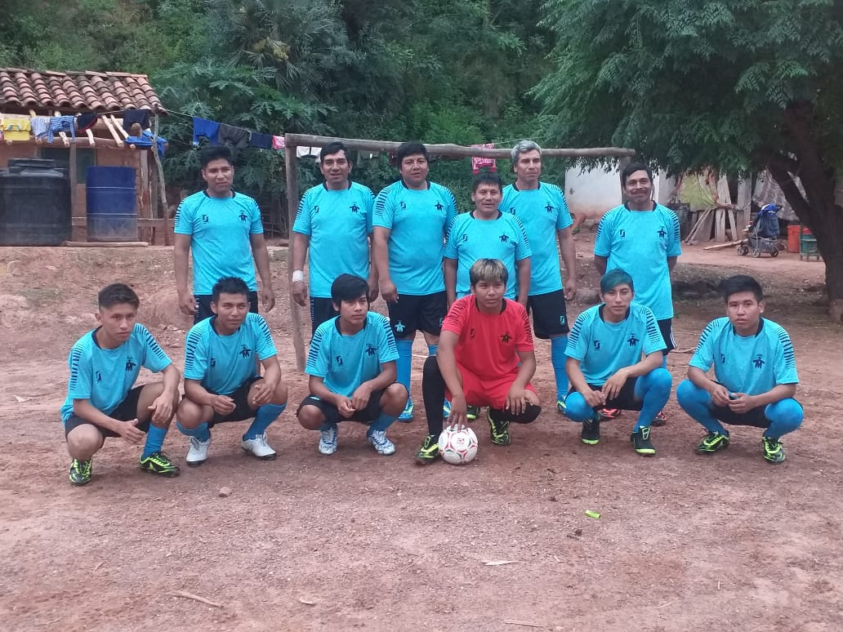
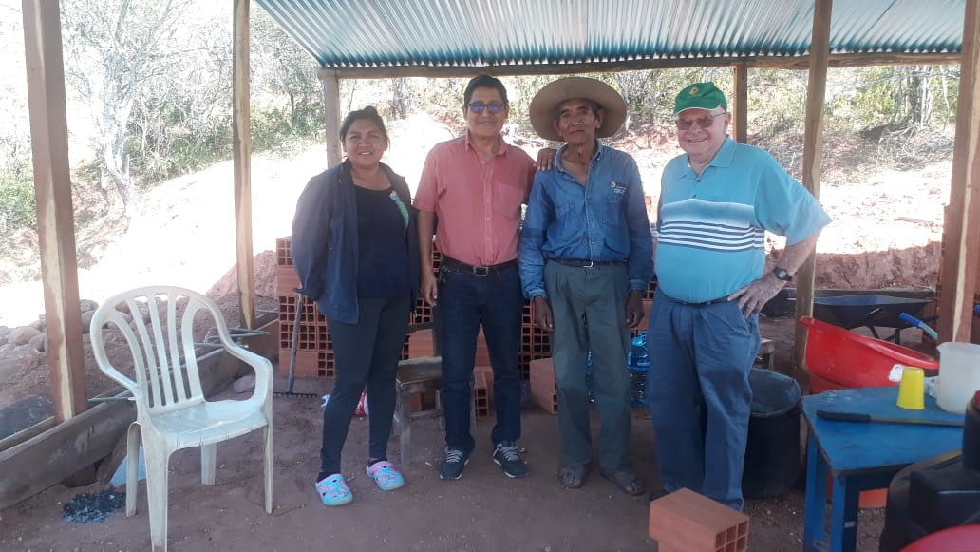
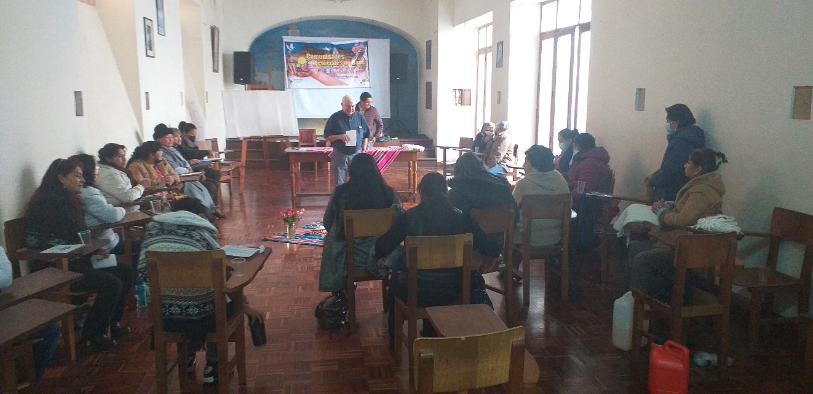
5. JUAN GIVING A PRESENTATION DURING A WORKSHOP IN MAY FOR THE CEBs ANIMATORS OF SUCRE ARCHDIOCESES

4. GILBERTO, JUAN & ALEJANDRA [Animator of Mokomokal] TOGETHER WITH DON RAMÓN [ELDER OF THE COMMUNITY] INSPECTING THE SITE WHERE RAMON’S NEW HOUSE WILL BE BUILT
2. JOHN [Juanito] TODAY
–A TRUE BOLIVIAN-CHAPACO

3. MOKOMOKAL SOCCER TEAM LAUNCHING THEIR NEW UNIFORM

1. THE 2 JOHNS AS BABIES [1945 & 2022]

